**Communication Skills**

A deep understanding of the process of communication and communication skills is essential. It is vital to the success of any individual in practical life. Communication is defined as “The activity of communicating i.e. the activity of conveying some information. Communication styles change from person to person. During the process of communication, a person may invoke several channels or modes or methods to convey a message. But, the process of communication doesn’t only depend on the source producing or relaying information. It equally depends on the communication method and the manner in which the receiver understands the message. Let us first understand the method by which we communicate.

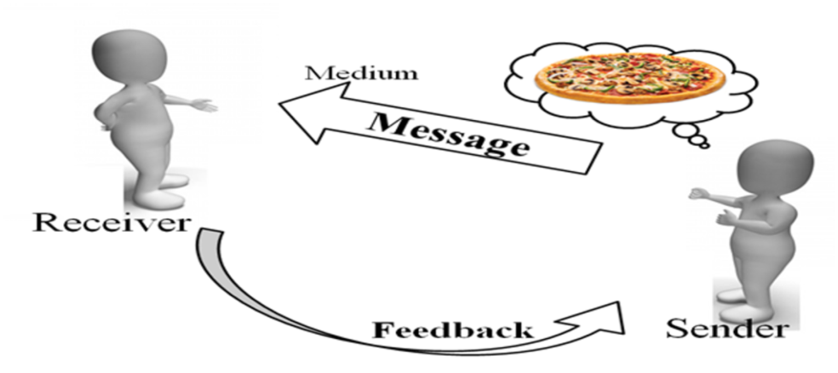

Communication begins at a given point. The first step is the generation of information. The second step is to put this information or data into a medium for transmission towards the intended audience. During this process, the initiator of the communication must pay extra attention to the nature of the information. The communication skills will determine the effectiveness of their communication. Let us now see what are the different types of communication below.

**The Main Kinds of Communication**

On the basis of the communication channels, types of communications are:

1. **Verbal**
2. **Non-Verbal**
3. **Visual**

**Verbal**

This involves the use of language and words for the purpose of passing on the intended message. In general terms, Verbal Communication means communication in the form of spoken words only. But, in the context of types of communication, verbal communication can be in the spoken or the written form. Thus, the verbal form may be oral or written as discussed below.

* **Written Communication:**This kind of communication involves any kind of exchange of information in the written form. For example, e-mails, texts, letters, reports, SMS, posts on social media platforms, documents, handbooks, posters, flyers, etc.
* **Oral Communication:**This is the communication which employs the spoken word, either direct or indirect as a communication channel. This verbal communication could be made on a channel that passes information in only one form i.e. sound.  
  You could converse either face to face, or over the phone, or via voice notes or chat rooms, etc. It all comes under the oral communication. This form of communication is an effective form.

**Non-Verbal Communication**

In this type of communication, messages are relayed without the transmission of words. The messages here are wordless messages. This form of communication mainly aids verbal communication. It supplements it with gestures, body movements, body language, symbols, and expressions. Through these, one may communicate one’s mood, or opinion or even show a reaction to the messages that are relaying. One’s non-verbal actions often set the tone for the dialogue. You can control and guide the communication if you control and guide the non-verbal communication. Some of the modes of non-verbal communication are:

**Physical Non-verbal Communication**

This is the sum total of the physically observable. For instance, hand gestures, body language, facial expressions, the tone of one’s voice, posture, stance, touch, gaze, and others. Several researchers have revealed that physical nonverbal communication constitutes about 55% of our daily communications. These are subtle signals that are picked up as part of our biological wiring. For example, if you rest your head on your palms, it will mean that you are very disappointed or angry. Similarly, other subtle hints will convey your reaction to the presenter or your audience’s reaction to you.

**Paralanguage**

This is the art of reading between the lines. The main kind of such communication is done with the tone of one’s voice. This kind of communication amounts to almost 38% of all the communication that we do every day. Along with the tone of voice, the style of speaking, voice quality, stress, emotions, or intonation serves the purpose of communication. And, these aspects are not verbal.

**Aesthetic Communication**

Art is an important means of communication. Through the paintings or other forms of art, an artist can covey the strongest messages. Several times in the history of the world, art has been used as an effective form of nonverbal communication.

**Appearance**

The first impression sets the tone. People will react to your appearance and this is a fact of life. Your clothes, the color of the fabrics, etc. all determine the reaction of your audience.

**Visual Communication**

This is communication through visual aids like photos, drawings, placards, presentations, and illustrations, etc.

**Formal and Informal Communication**

Apart from the above types, we have formal & informal types of communication. Formal communication is of following types:

* **Vertical:** The information or data flows up and down the organizational structure.
* **Horizontal:**This is the communication between two similar levels of the organization.
* **Diagonal:**This is the communication across the cross-functional levels of employees from various departments of the organization.

The other form is the informal or casual communication which is the general communication between random people of the organizations.

**Example**

Q: Of the two forms of communication, i.e. verbal and nonverbal, which constitutes for the larger flow of information?

Answer: One might think that verbal communication is the dominant form of communication. But as per researchers, 55% of the communication is **Nonverbal**. So, the nonverbal form of communication contributes more to the flow of information.